EXERCISE-3

3. ReactJS-HOL

Create a react app for Student Management Portal named scorecalculatorapp and create a function component named “CalculateScore” which will accept Name, School, Total and goal in order to calculate the average score of a student and display the same.
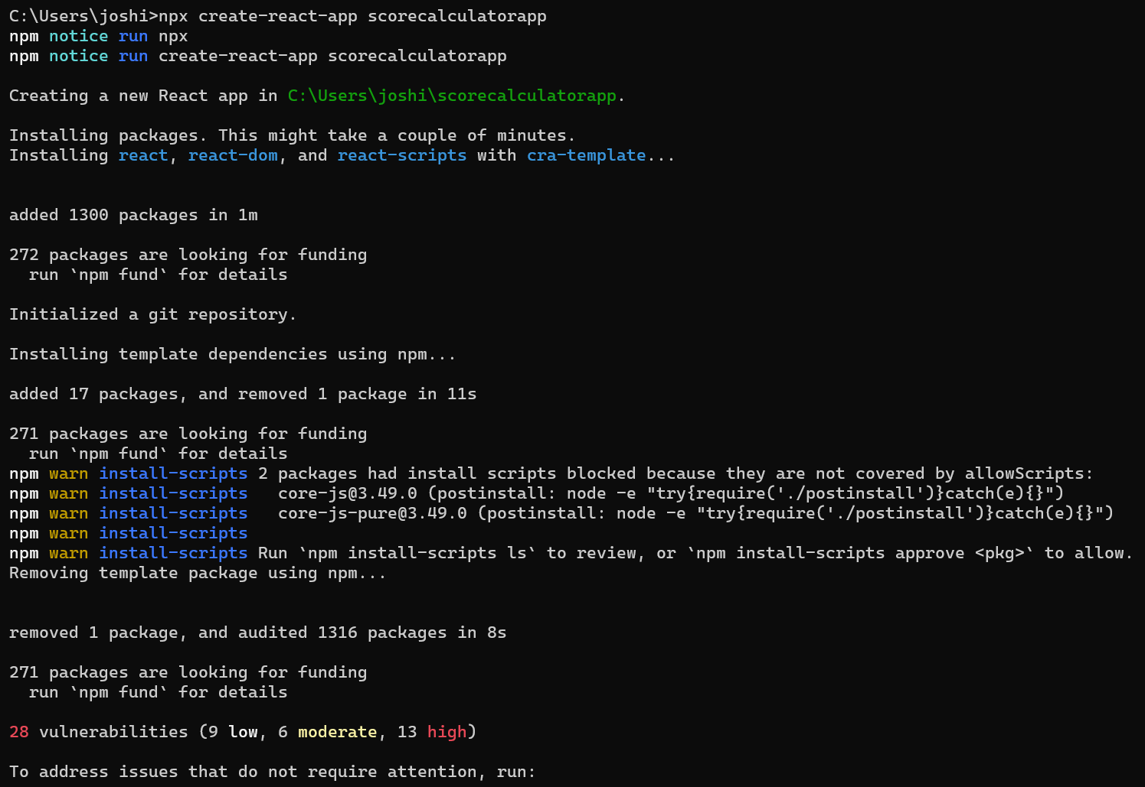
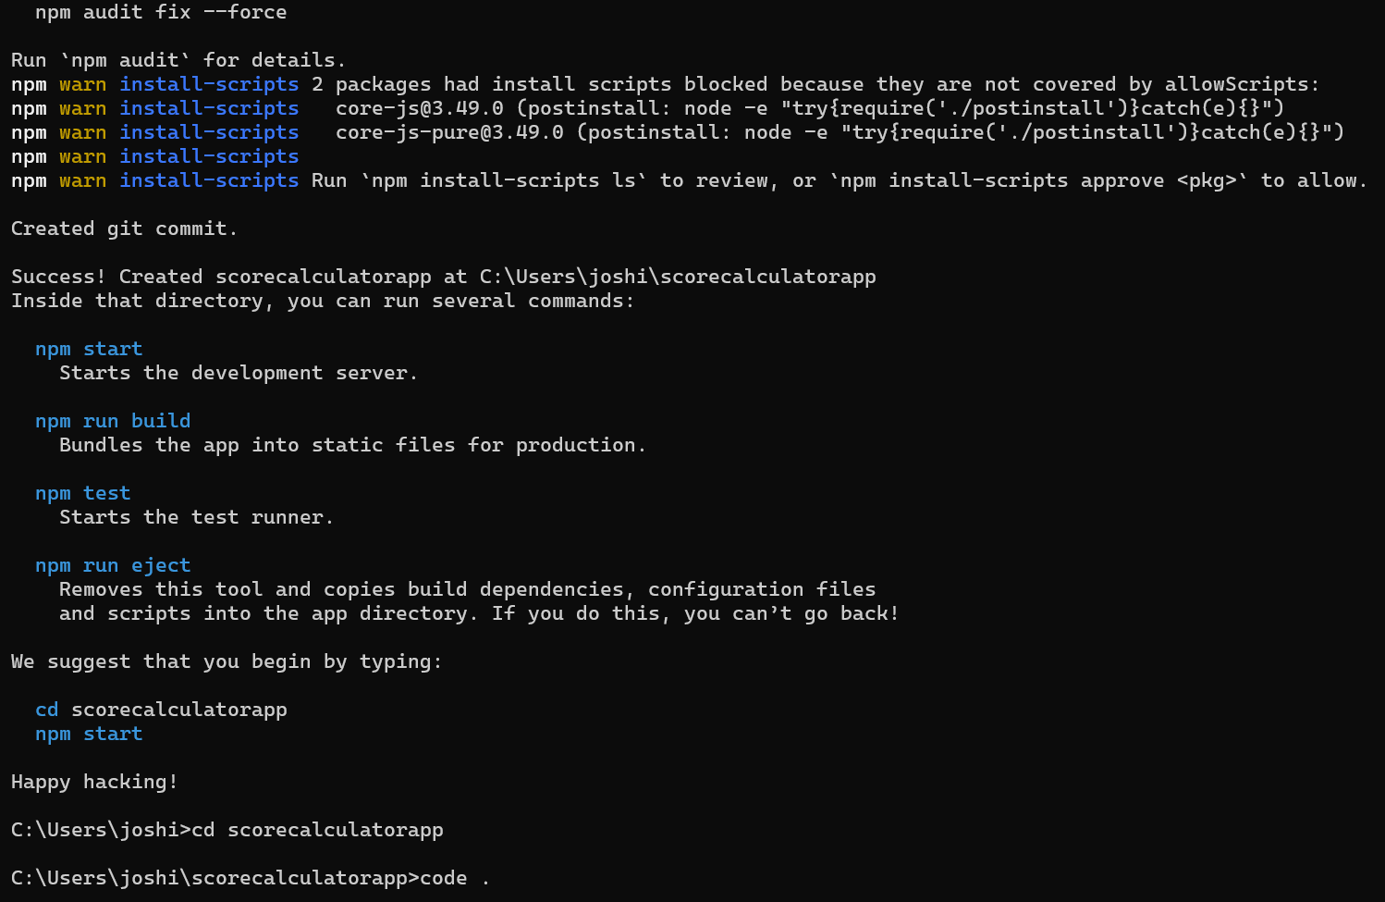
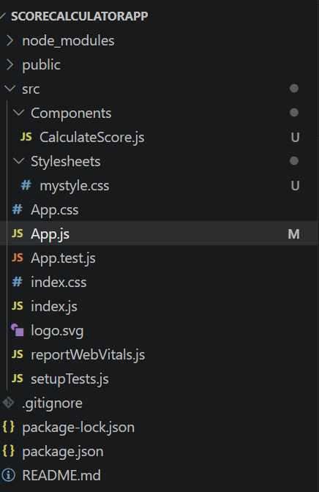

CalculateScore.js:
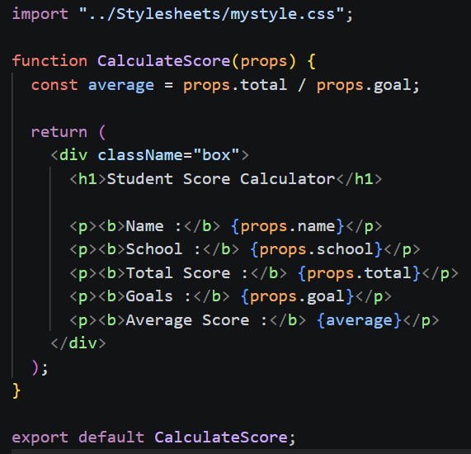

mystyle.css:
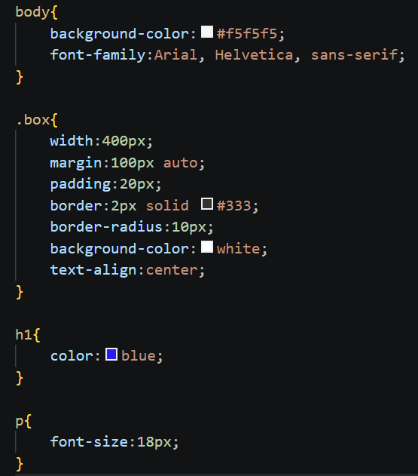

App.js:
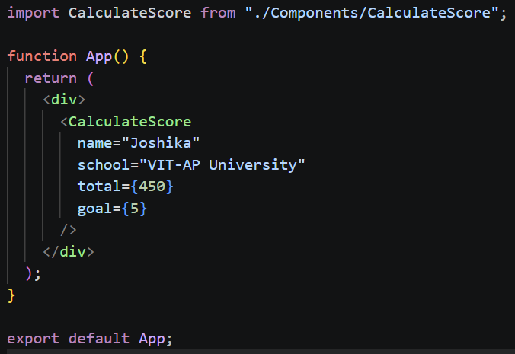

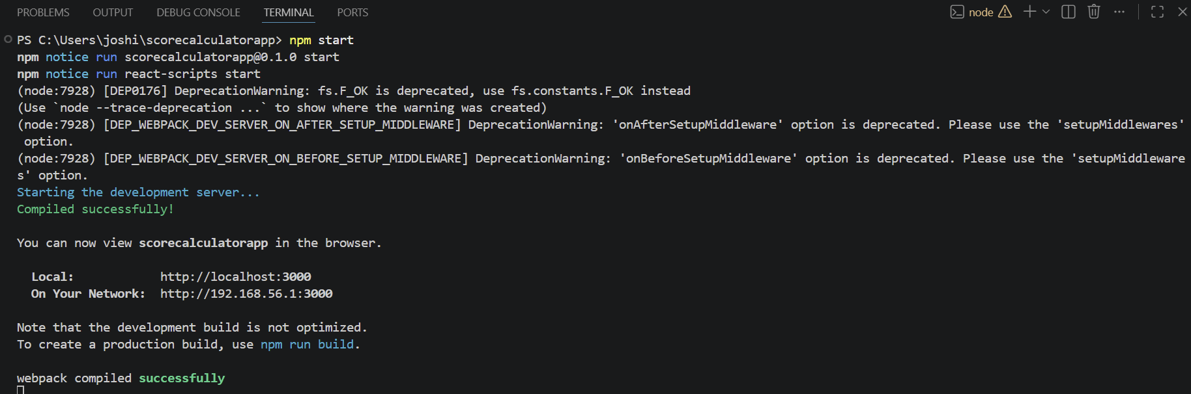

OUTPUT:
